The UX of Health Insurance

The state of South African Health Insurance
Websites in 2020

Part 4 of 4

This is Part 4 in a series of 4, where we explore the usability and patient experience across the websites of the most popular Medical Aid companies in South Africa. You can find Part 3 here.

If you’re in a rush…

- Our team of design experts assessed 16 healthcare provider’s websites against a set of usability standards in the Feature Inspection phase of The Sand Dollar Design Heuristic Framework.
- Plan Comparison is the best implemented feature with nine out of 16 providers scoring excellent for their implementation, allowing users to easily compare medical aid plans. Customers expect this feature on medical aid provider websites.
- It is important for potential customers to be able to view network hospital locations, however this is the worst implemented feature with seven out of 16 providers either not including it or delivering a poor experience to their users. Customers may not sign up with a plan if they are not sure which nearby hospitals they are able to go to in case of an emergency.

Intro

In Part 4 of our series on the state of South African Medical Aid Websites in 2020, we will be sharing our insights from the Feature Inspection that we conducted.

Feature Inspections are used to evaluate which features are available in a product in comparison against its competitors, as well as, how well these features have been designed and implemented. We use usability standards and heuristics to help identify best practice and determine whether a product is functionally acceptable.

Who did we evaluate?

Our team of researchers evaluated the websites of (alphabetical):
Affinity Health, Bestmed, Bonitas, Discovery Health, Fedhealth, GEMS, Genesis, Medihelp, Medshield, Momentum, Polmed, Profmed, Selfmed, Umvuzo, United Healthcare and Vitality.

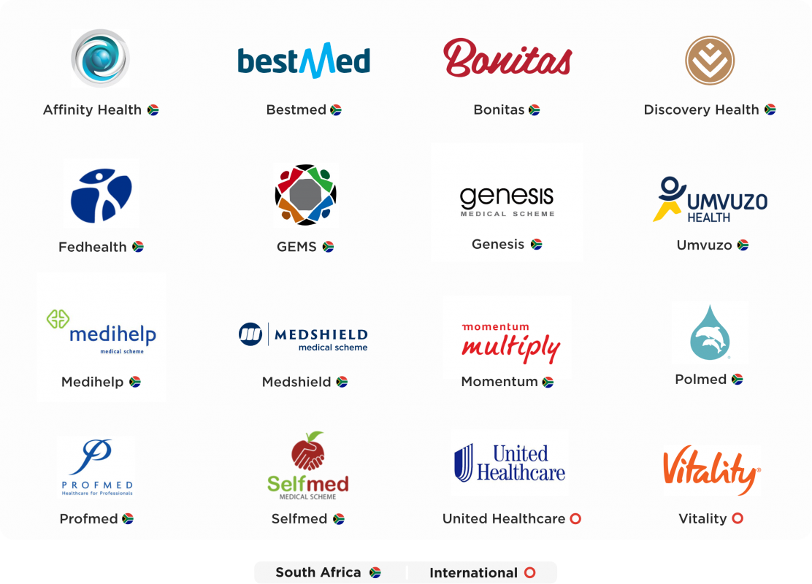

What was our method of evaluation?

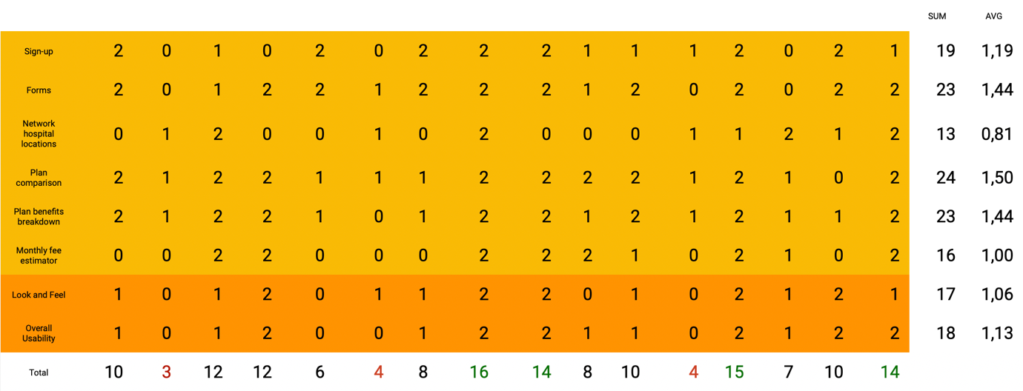
Figure 1: Spreadsheet used to track our assessment of each feature as well as the functionality of each medical aid provider.

We assessed each healthcare providers website in terms of its features and functionality. Features are the things that you would expect to find when using a product. For example, on a website such as YouTube you would expect to be able to browse, search and view videos. We assessed each medical aid provider’s sign-up process, as well as, how they collect user data through forms. We also assessed whether it is possible to view network hospital locations, and whether websites give users the ability to compare plans in terms of monthly benefits and financial contributions.

Once we had a good understanding of each website’s features, we could assess functionality. Functionality refers to the quality of a website, assessing the look and feel as well as the overall usability. ISO-9241 defines usability as “the extent to which a product can be used by specified users to achieve specified goals with effectiveness, efficiency and satisfaction in a specified context of use.” This being a expert review we used our experience to help us identify areas where users may or may not be able to achieve common goals with effectiveness, efficiency and satisfaction. An example of a product with good functionality is Microsoft Word which utilises aesthetic and minimalist design to make it pleasant to use. Additionally, the toolbar above the canvas in a Word document lists out common actions such as Insert, Draw, Layout and Review. If a user wants to add an image, blank page or title to their document all they need to do is click the Insert toolbar tab to find the feature they are looking for.

* Some information was hidden behind a login, however for the purpose of this assessment we tried to complete these tasks by using the information provided on each website.

What are our key insights?

We were able to identify the best and worst implemented features, as well as overall trends across all healthcare providers 16 providers.

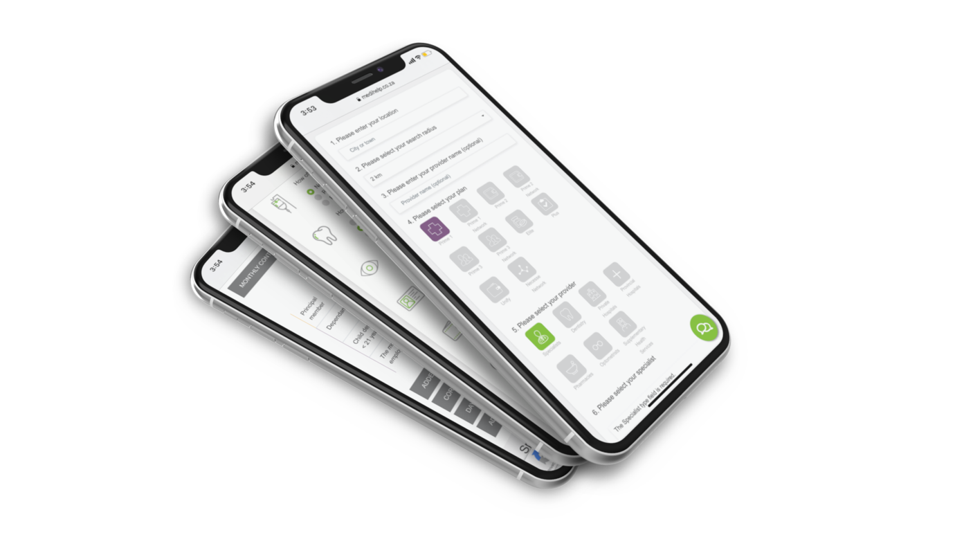

Best Implemented Feature

Plan comparison is the best implemented feature that we assessed. This feature enables users to browse and compare a medical aid plans. Comparison can be made in terms of benefits, monthly fees or preventative care to name a few.

This feature saw a combined success rate of 75% across all healthcare providers. Nine out of 16 providers scored excellent for their implementation, with six scoring good and one provider scoring poor.
One of the ways that we differentiated between excellent and average design in this feature category is by referring to usability standards such as Jakob Nielsen's 10 general principles for interaction design. Principle six, recognition rather than recall, tells us that good design should, “Minimize the user's memory load by making objects, actions, and options visible. The user should not have to remember information from one part of the dialogue to another.”
We rated a healthcare provider’s plan comparison feature as excellent if it allows users to view or pin multiple plans alongside each other, instead of having to click back and fourth between different plans, potentially forgetting important information in the process.
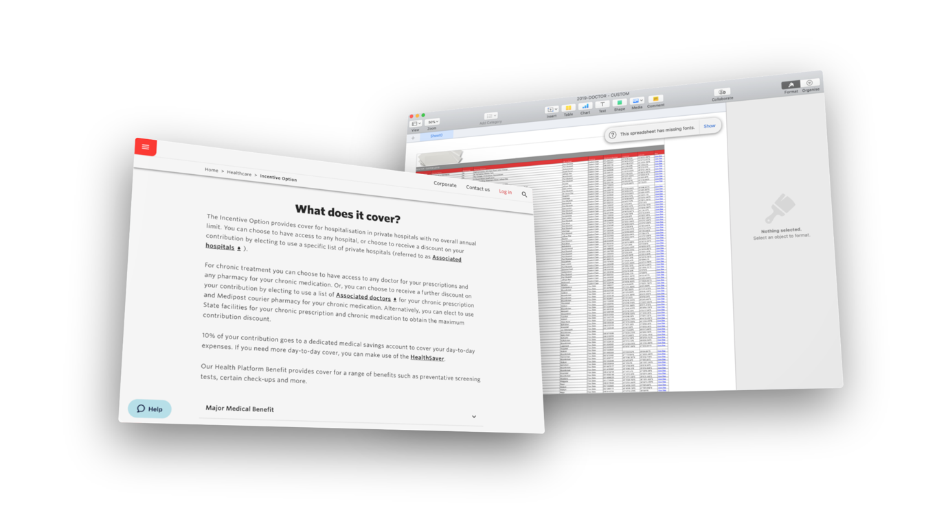

Worst Implemented Feature

One of the questions potential medical aid customers may be asking is, “Which Hospitals would I be able to use under each plan?” Unfortunately this is a feature missing or poorly implemented in many healthcare provider’s websites.

This feature saw a combined score of 40% across all healthcare providers, with only three out of 16 providers scoring excellent, five scoring good and the majority of seven providers scoring poor for their implementation.

One especially poor example from a prominent healthcare provider requires users to download a Microsoft Excel file containing a long list of their partner hospitals. Apart from potentially confusing users by sending them outside of the website to obtain critical information, or by potentially preventing them from viewing the list due to not having Excel installed on their device, giving users a long list of disorganised partner hospitals will most certainly result in information overload resulting in most users giving up and moving onto a competitor website. A simple solution to this problem is allowing users to search or filter hospitals based on location.

Overall trends

We noticed a trend in which websites with poor usability, also tended to not be catering for features that users may expect to find such as online forms, interactive rate estimation, and plan comparison. These websites instead require users to print out, fill in and email PDFs, contact a call centre for a quote as well as jump back and forth between pages just to find the best plan for their needs and budgetary constraints.

Considering customer questions and needs when designing a website is critical to the success of your business, especially keeping in mind that when a user is required to dig for information they will often just go to your competitors instead of trying to figure out your poorly designed system.

In summary

With that we have completed our 2020 heuristic review of the South Africa’s healthcare providers. Along the way we have seen that medical aid providers who consider usability standards, identify user needs and expectations, as well as, implement common features with robust functionality have a high chance of delivering a user experience that not only meets user’s needs, but also delights them and increases their brand loyalty.

We know that UX gives a minimum return of 2X the amount you invest into it (typically even more). With that in mind it makes sense to invest in designing products which ensure the best experience for your customer / prospective customer.

We would love to partner with you on your next project to ensure that this happens.

Find out more

If you are interested in more detailed insights and finding out more about this study, request a detailed report on our findings.

About Sand Dollar Design
Sand Dollar Design is an Experience Design Consulting firm, with a focus and passion for re-imagining the Patient and Provider experience through Digital Health interventions, in order to achieve improved Healthcare outcomes for all.

Find out more about our services at www.sanddollardesign.co.za

